**Masanga UK (charity number 1136339)**

**Board of Trustees and Officers**

**Resumes**

**Dr Austin Hunt – Chairman and Trustee**

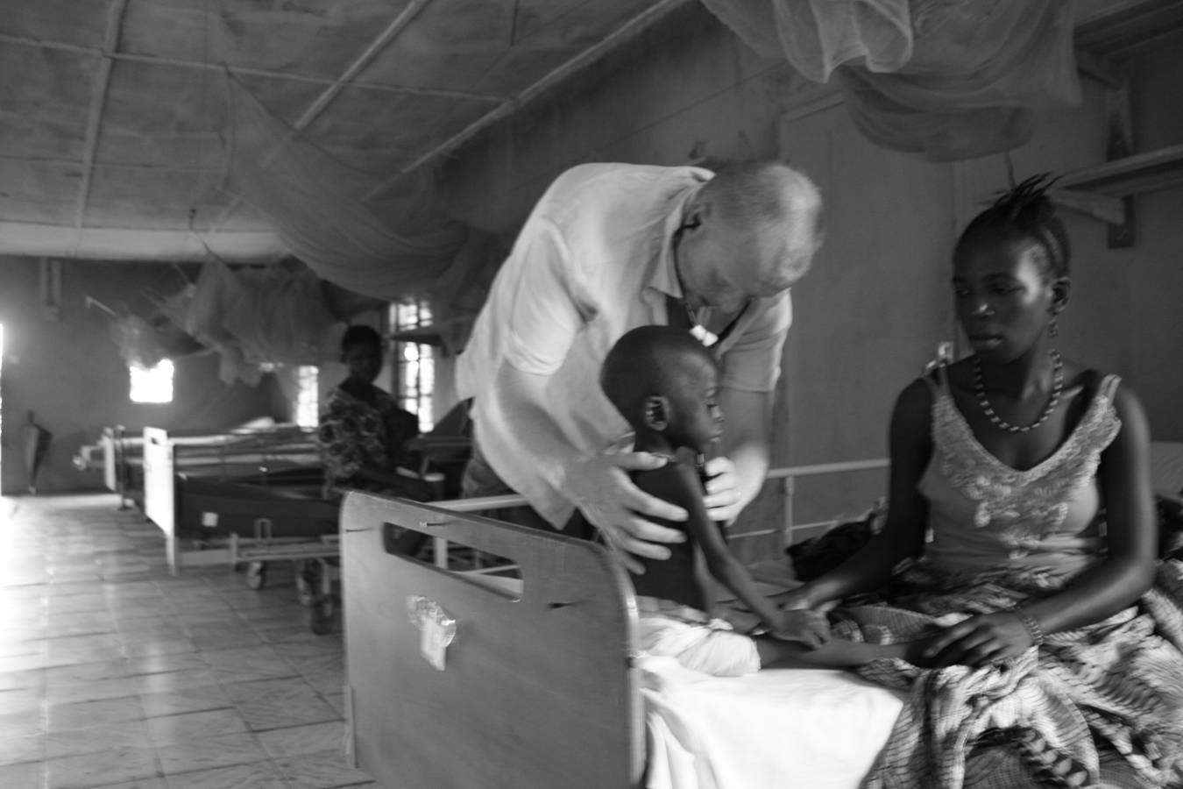

Dr Austin Hunt MBBS BSc DTM+H MRCP is a Consultant Nephrologist and Physician at Plymouth NHS Trust. Qualified as a Doctor in 1996 at Royal Free Hospital School of Medicine and has a long standing interest in Global Health. In 1992 intercalated at UCL and the London School of Hygiene and Tropical Medicine and in 1996 was awarded the Post Graduate Diploma in Tropical Medicine/Hygiene at the Liverpool School of Tropical Medicine. Appointed as a Consultant Physician, Derriford Hospital, in 2008, and Director of Acute Medicine in 2013. Founder Trustee and currently Chairman of Masanga UK. Main role on the Masanga Board is the liaison with the Peninsula Medical School and recruitment of Plymouth NHS Trust staff to support clinical services at Masanga.

*Dr Oz in the Paediatric ward in 2009*

**Geoff Eaton – Trustee and Masanga UK representative on the International Board**



Geoff Eaton ACA is a business leader who was formerly Chief Operating Officer of Premier Foods Plc, Chief Executive of Uniq Plc and Chief Executive of Isis Research Plc. His involvement in Masanga started when his Brother in Law, Dr Oz Hunt, persuaded him to run a mountain marathon in aid of Masanga in 2010. He visited the hospital in Sierra Leone in January 2012 and joined the International board of Masanga in October 2012. This year he will run his 4th mountain marathon with his eldest son Patrick and hopes to continue to raise funds, generate awareness for this unique international initiative and work on the long term sustainability of Masanga.

An unlikely DJ at the Masanga village disco

**Lt Colonel Dr Simon Horne – Trustee**

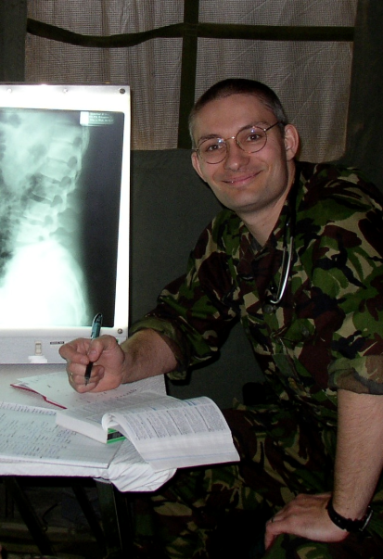

Dr Simon Horne FCEM DIMC DCH DMCC qualified from Oxford in 1996 and is an Emergency Medicine Consultant at Derriford. He joined the Royal Army Medical Corps and a variety of deployments and expeditions gave him an interest in the practice of medicine in resource–constrained areas. He leads a module of the Masters in Remote Medicine at Plymouth, and also works as a medical officer for the British Antarctic Survey Medical Unit. His current focus is on recruiting doctors to work at Masanga and supporting them as they undertake sustainable improvement projects while they are there

**Professor Nigel (Ben) Benjamin - Trustee**

Nigel (Ben) Benjamin FMed.Sci, FRCP, DM is an honorary Professor of Medicine at Plymouth University Peninsula School of Medicine and Dentistry and University of Exeter Medical School. He trained in Nottingham and came to Devon in 2003 after leaving Barts and The London as head of the William Harvey Research Institute. He now works as an acute physician at Torbay Hospital in Devon. He became involved in Masanga after visiting the hospital in 2009 and was one of the founding Trustees of Masanga UK. He continues to have an interest in developing research projects with UK students who spend time in Masanga.

ben in sl.tiff

**Helen McMillan - Trustee**

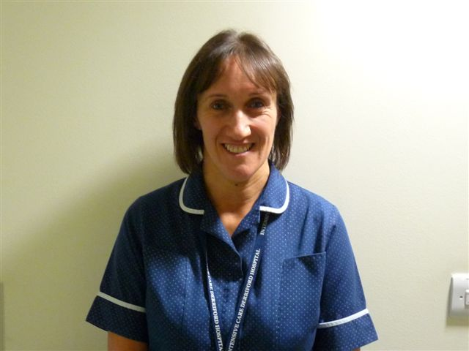

Helen McMillan BSc is a Critical Care Sister and Clinical Educator at Derriford Hospital, Plymouth. Helen is the newest recruit to Masanga UK and has joined the team to develop nursing links with Masanga. Helen is due to make her first visit to Masanga in January 2014.

Helen has joined the fund raising efforts and despite not been a fan of running is due to do her first Mountain Marathon in October.

**Mike Green – Trustee and Treasurer**

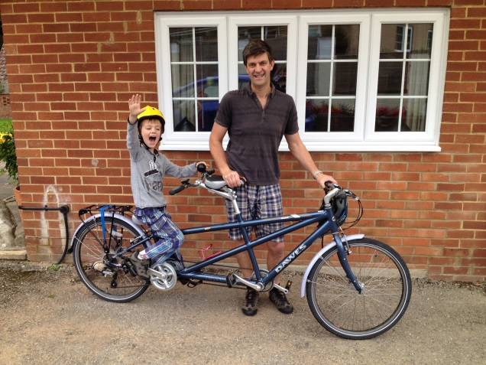

Mike Green FCCA is a finance professional who has spent over 30 years working in industry. Currently a Risk Manager at Greencore Plc, having previously had roles as Group Controller and Compliance Manager at Uniq Plc. His first association with Masanga UK was in mid 2011, when he took over the role of Independent Accountant to ensure that the Charities robust financial management and legal responsibilities are maintained. Mike joined the full UK Trustee Board in 2012, while continuing to take responsibility for ensuring that the charities finances are wholly focused on the Hospital in Masanga.

**Dr Jack Pickard - Publications Coordinator**

Dr Jack Pickard BMBS graduated from Peninsula Medical School in 2012. He currently works as a junior doctor in nephrology at Plymouth Hospitals NHS Trust. His involvement with Masanga began when, as a medical student, he travelled there and worked in the hospital for his medical elective. Since then he has supervised other medical students in their electives at Masanga, and overseen various projects in tropical disease research and hospital audit. He took the lead in equipping the hospital’s Emergency Admissions Unit with medical devices. His most recent project is to begin street fundraising for Masanga Hospital.

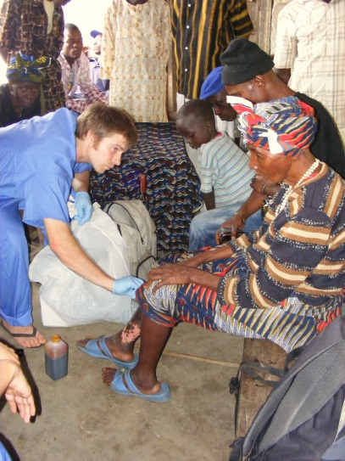

**Dawn Holwill - Trustee**



Dawn Holwill, Ba Hons Business Management and Leadership. Has worked for Plymouth Hospitals NHS Trust for 12 years. Currently employed as a Medical Secretary but will be taking up a post as an Ambulatory Care Coordinator in the near future. Her involvement with Masanga began when she was asked to type up a report for Professor Ben Benjamin and Dr Austin Hunt following a visit to Masanga in 2009. She currently deals with the administrative side of the project. She is hoping to visit Masanga in 2014 with a view to implementing safe and effective medical record keeping.