Masanga Diary

I spent nearly three months at Masanga, as a visiting doctor, in the early part of 2013. It is not only a hospital, but also a lifestyle, an adventure and a frame of mind. It was an incredible experience. I have edited my diary for public display and posted it below.
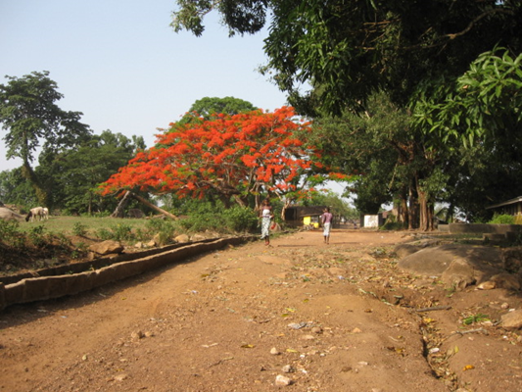

28thFebruary
Welcome to Masanga. Literally got out of the car to say hello and was directed to theatre to find Alex and Josein looking at an immense cervical fibroid. Please scrub and tell us what you think! So, now as the new Gynaecologist from England, fresh off the plane with no time for a pee, I found myself scrubbed into an operation on a woman I hadn’t met, a large expectant audience, for the hardest operation I’ve ever done. A least I could blame my sweating on the heat. Several times I wondered if I was dreaming. It was tough and she needed 3 units of blood from the relatives outside. Post op she looked dreadful, comatose following her Ketamine anaesthetic, with a Pulse of 110, BP of 80/50, blood stained urine and Hb of 6.9. Alex didn’t seem so worried and reassured me they all look like this following Ketamine. I thought it more likely she would die, but took comfort in his advice and hoped for the best.

1st March
She lives! Truly a miracle. It would also seem that not only is she alive but her ureters remain intact and she smiles. ‘I feel much better doctor’. Wow.
Ward round on the Maternity ward with Aliou is a humbling experience. He is one of the Surgical Training Program students I have apparently come to teach. He clearly has immense knowledge, grace and tact. In this environment there seems little I can teach him. We see a woman with immense hepatomegaly, emaciated, and also about 30 weeks pregnant. ‘What shall we do Doctor Adam’, the family want to know how we will treat her. I forgot the magic wand I realise. Still we stall for time by agreeing to transfuse her, HB 6, and think some more.
More women wanting delivered, fed up with belly and want picken out now. I’m used to this but not in the context of not knowing the gestation. Measures about right. Let’s do a stretch and sweep. Sorted. Plan is interrupted by a labouring woman, as always never prepared to wait in line and PPH. All fine in the end.
Dinner with Josien and Bart in the evening. I find myself volunteering to share the on-call with Josien and Alex so we can do 1:3 instead of 1:2. That’s Medicine, Surgery, Paediatrics and O&G! Let’s see how it goes this weekend……

2 March
Running this morning with Christopher and Christian, Danish volunteers. They are clearly a bit more used to the heat, even at 0730.
Rounds with Joseph and Josein. Working diagnosis on the woman with Hepatomegaly is hepatocellular ca secondary to Hep C………We’ll also check for Bilharzia and transfuse her. The rest of the pregnancy could be rough. Turns out one of the women I did a VE for yesterday and fortunately had a closed cervix has a placenta praevia on USS. When will my luck run out?
Old fellow with swollen belly. Previous hernia repair. Clear obstruction, so we resuscitate and book for theatre this afternoon.
Lunch. I am being looked after like a lord. Rigi is the cook and housekeeper at Reike’s house, and sees me right breakfast, lunch and supper. Mr Education looks after the house in the day. I even apparently have the right to drive the Capacare truck. It is your car! I’m a bit more taken by the idea of a bike from the Masanga Bike store.
Laparotomy goes well. Pa has a volvulus around an adhesion between his small bowel and the hernia repair. Now he has a chance and I begin to think that there is much we can do.
Bam!
‘We have lost a patient doc’. The lady 3 days postnatal has fitted and died, whilst we were in theatre with Pa’s volvulus. I am not really able to take in the serenity with which this news is delivered. It turns out she had been fitting on/off since delivery. I wish I had gone to see her with Joseph when she arrived. Why didn’t we get called from theatre?..... Probably would have made no difference.

3rd March

Pa died in the night. Not sufficiently strong to pull through the laparotomy. Saw a few other patients and discussed yesterdays unexpected maternal death.
Sunday and therefore quiet about the hospital.
Animals spotted so far in Sierra Leone: cows (on the way from Lungi); chickens, ducks, lizards, goats (plenty), monkeys in the trees here at Masanga and dogs. Mr Education has 3 dogs who stay here with me at Reike’s house.
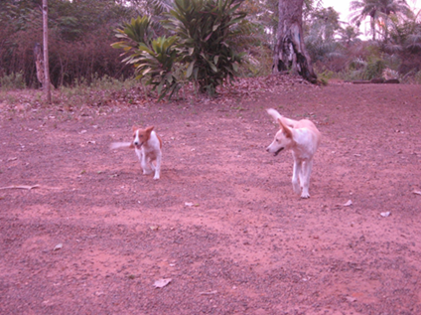
Cheer Lady and White Boy
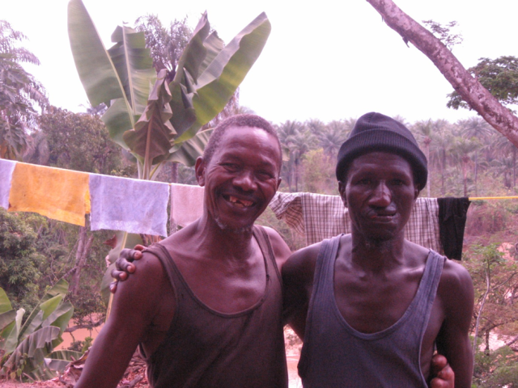
I hear Mr Education is the best snake catcher in the land. I spoke to him about it today but in the dry season (until April), they all stay own by the river anyway. Cobras, black ones, about 2m long. Spit in your eyes with deadly accuracy which causes blindness, and then if they like the look of you (if you small like dogs/rats) they eat you.
Mr Education and George
Also had long chat to Bart and Josien this morning about trouble at mill. Currently there is nobody to replace either Josien or Alex as the medical officer in charge when they go in April and May respectively. I can see the pressure that they feel to extend beyond that time to safeguard the continuity of the hospital. At the same time not wanting to release the Board of their duty provide the next doctor. It may be possible for Sierra Leone trained people to take over in the course of time, but not yet. There is also a funding problem. Currently their posts and much of the money spent in the hospital comes from the private practice of Peter Bo in Denmark. He can’t sustain it at this level. The government is unwilling to help, perhaps because there is already a hospital about 30mins away.
Time to plan some teaching for tomorrow: Management of labour and the partograph.

4th March
Tough day
Mangoes landing on the roof last night like rain, except the drops being the size of rocks; a metaphor for life in Sierra Leone with an enormous attrition rate before maturity. Not much sleep therefore, but did manage to meet Christian for a run.
Ward round followed by some scanning which is at the top end of my capabilities. Josein is pretty slick with the machine. We did manage to convince ourselves however that placenta praevia lady was 24mm from the internal os and therefore for a trial of vaginal birth.
Saw a woman with I thought 34 weeks pregnancy, fever, abdominal pain. Shortly afterwards ruptured her membranes and began to labour. That’s when it went south as her baby died in labour, quickly becoming bradycardic, and dying before we could arrange a Caesarean. Perhaps things would have been different with a CTG.
5th March
Vivid dreams last night in which I played the part of an unreliable and absent minded father and husband!
SteadyBongo was spinning a few discs in a nearby village, but it felt as if I was next door. Apparently he’s coming to Masanga next week.
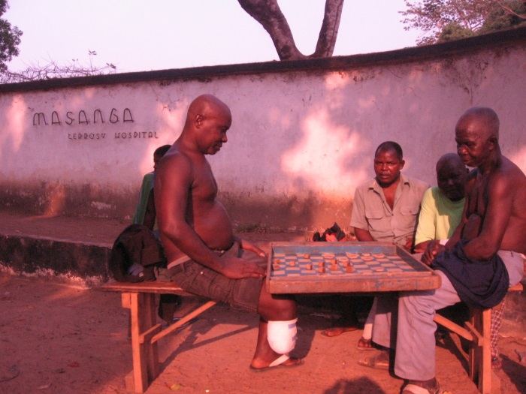
Anyhow a much better day today. I did a vaginal hysterectomy with Josien for a procedentia, and took Mathew, one of the Surgical Training Programme doctors through a laparotomy and ovarian cystectomy. Both cases went well and I feel a sense of relief. We did have another maternal death today, but this was not such an unexpected event. The lady had an enormous hepatomegaly and had a poor prognosis in any event. She was however 32 weeks pregnant and the mother of one other child.
I spent a few minutes chatting to some old guys at the hospital gate playing draughts. I’ve been challenged to a game tomorrow!

On the way back in found a child in the admissions ward with a deep wide laceration down the middle of her face, from the bridge of the nose through the palate and the mandible. Apparently struck in the face with a chain saw. She is 6. We took her to theatre for an exploration, limited debridement and assessment of her airway. Sadly it is a complicated injury that would be a challenge in the best of settings. Here she will struggle to survive with the airway, feeding, and infection problems. Alex has a contact with the Mercy Ships in Conakry, who specialise in cleft palate surgery and may be able to help.

7th March
Busy days. Yesterday up for Caesarean at about midnight. Obstructed labour but all ending well. In fact 3 live births yesterday which is a bit of a good result on recent form. Then this morning we had the classic obstetric dash to theatre with a cord prolapse in twins, and again all turned out roses. 2 laparotomies, one an ovarian abscess and the second a hysterectomy for multifibroid uterus. Both went well. Just before heading over the Alex’s house for dinner, called to see a lady who had been brought in comatose having delivered yesterday at home and bled afterwards. I suspect she is not long for the world with a significant neurological insult, although we will support her and see what comes of it.

Had my first mango today as they are starting to ripen. Fabulous. Also Pineapple. Some of the luxuries of the land. Best take advantage of them.

8th March
Slept sound last night and woke up feeling ‘fine’. It seems everyone is ‘fine’ when asked how they are doing: ‘how are you?’ ‘I’m fine’. Apparently other answers are’ I’m preparing to be fine’, or ‘average’. (Probably not very good).
It’s women’s day today and hence a public holiday apparently. As Alex said ‘why not, it’s been 4 days since the last one’. It turns out that Rigi and Education have been looking to me to give them they day off! I am truly a lord here.
After a good morning trot down the road, headed into the hospital. Good news on a few fronts: PPH lady is somewhat better and now responds to voice, but still not really there. I did think it might be a profound psychological response to events until we managed to overload her with fluids and tip her into pulmonary oedema which certainly didn’t help….she has a long way to go if she is to recover. Both yesterday’s cases hysterectomy and oophorectomy doing well. My diagnosis of ectopic proved to be correct and laparotomy/salpingectomy went well.
Played football with the amputees this afternoon as part of their physio programme. A bit of a crowd puller with the hospital amputees taking on all comers
Cold beer at the hostel on the way home. A very friendly bunch the Danes. It’s hard to see them as Viking Warriors. Party tomorrow night at their gaff in honour of somebody returning home after spending the last 6 months here. Went to fell some palm fronds to help them build a bar. The entire village seems to have been invited so it might be a big occasion.

9th March
Saturday.
All quiet. Got up for a long run with Christian and Christopher. About 15kms on a loop through the villages of Masanga 2, Rugbuska, Matam, and Masanga. Overcast, but still very sweaty.
Bit of a lazy start afterwards enjoying grapefruit and omelettes for breakfast.
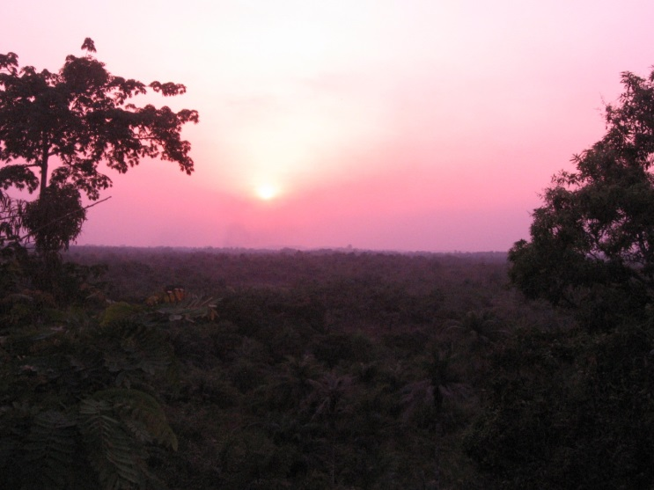
Saw the generator was on, as the lights in my house came on so headed into the hospital in the anticipation of finding Alex in theatre. I had said that I would help him out today. He had in fact done the ward round and was draining an abscess in theatre.
Quick check of the patients and then back for lunch. Chips with tomato sauce.
Climbed the water tower on the way, which affords a great view across the country to the west and would be a good place for sun downers, so long as a little co-ordination is left to negotiate the climb down again!
The tower itself supports a huge tank which is feed from the well by means of solar power, but there is a problem with the pipe work between the tank and everywhere else. Currently there is only a single tap that runs water, and that at the base of the tower. I understand that in pre-war times all of the houses and the hospital had running water. Christian is in charge of trying to fix it. Unfortunately there is a valley between the tank and the hospital that requires that the water run at high pressure through the pipes to make it up the other side. ………

10 March
Sunday. Good party last night. Sampled the dubious delights of palm wine. It smells like rats piss and tastes much the same. It seems to be quite an acquired taste as Joseph was keen to get stuck in.
I was having a snooze after last night’s party when Gregor and Thomas arrived. Radiologists form Trondheim. It’s good to have some others in the house and I think they are here for 2 weeks. There are 3 machines here and 2 of them work. All 14 of the STP students are coming from their placements all around the country for 2 weeks of scan training.
I went in to the ward this morning to find Amie, (Massive fibroid lady) has, I think, developed a fistula. This is bad news, and very disappointing. I think it is not unsalvageable, but will need another operation in which I am no expert.

11th March
Rain. Thunder and lighting in the evening sky highlighting huge cumulus clouds.
Managed to get through to home on the phone this evening from the water tower and got 13 mins for just under 10 000 Leones. That’s about £2. Bargain. Hard to reconcile the -3 degrees and ‘snow storm’ at home with the 30+ degrees here.
2 Caesareans today which went well.

12th March
Difficult day. Amie has almost certainly got an iatrogenic ureteric injury. Ascites with hydronephrosis on the right side. Shit. This is going to be difficult and I’m not really sure how to manage it.
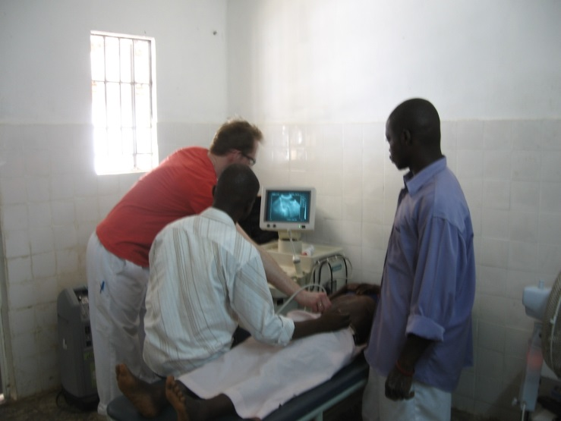
Also had some more interesting work come my way today……With the Radiologists from Trodheim come scans and with that problems….They like bringing them to me! I found myself draining an abdominal abscess today in a man that I think is probably related to appendicitis. I don’t think it will appear in any O&G textbook. Alex and Josein seem happy to let me take on these cases and I am sure they are grateful for somebody to help them share the responsibility of it all. Just anxious not to cause unnecessary complications. Doing the on call is a huge departure from simple O&G. Thankfully having some surgical experience helps. Paediatrics is the most daunting and the kids are certainly pretty sick when they get here.
Ultrasound training

14th March
Africa! Big rain yesterday, and the stream and gutters overflowing. The ‘Big Store’ looked as if it was taking up place in the middle of the torrent. Rain everywhere even through the theatre roof! Also had issues with the generator yesterday as the diesel was running low the main generator had to be switched off. Previously the generator was written off when it ran out of fuel. The reserve generator was insufficient to power the theatre lights and Caesarean performed with a head torch. I was on neonatal rusus for this one so Josien did the heroics.
We had supper at the hostel last night and coffee to follow with Alex and his wife Annemarie. Good chat to Alex about the project and he has asked me to look after the hospital whilst he and Josein go to a conference in Freetown.

15th March
Amie seems to be holding her own and persuaded me to buy her her favourite drink ‘Mega Cola’ , from the canteen. I’m just pleased she is drinking. Took out her drain today for fear of infection, but she still has a catheter. Alex inspires me with his hope….time will tell.

17th March
Sunday evening. Hot and sticky despite being 8pm. Just back from the Masanga farm which is about 20mins walk down the road (track). Goats, pigs, chickens, guinea pigs (for playing with rather than eating I think.
A delightfully tranquil place. Francis is the caretaker of the operation and took obvious joy from showing us around the place.
The pigs are sold on special occasions like Christmas and Easter. Goats perhaps more frequently.
Spent some time at the hospital again today. First up a young woman with fever and abdominal pain for 2 days. Ultrasound demonstrating swollen bowel. On the presumption of Typhoid we took her to theatre. She certainly had small bowel inflammation involving a significant section of her proximal ileum, but no perforation. Alex thought it an unusual pattern for typhoid so Crohn’s is in the differential, but an infective pathology seems more likely. Second today was a pregnant woman with a dead fetus at about 30 weeks, with history of previous Caesarean. Alex saw her yesterday and asked that I rescan her. I couldn’t really understand why, but on scanning it was clearly extra-uterine. Laparotomy revealed a dehisced scar with both baby and placenta in the abdomen. On further questioning this evening she describes pain and probably ruptured her uterus about 10 days ago!
I was taking Shami (STP student) through the operation, when we got news of an eclamptic in the emergency room: Fits at home; baby is alive with estimated gestation of 31 weeks; Magnesium, Steroids and see how she goes over the next 24-48 hours. If she fits again we will have to deliver her. The baby has no chance if really 31 weeks.
Also on the Emergency Unit tonight is a man with crushed hand following a mining accident, another chap with the intraabdominal abscess I drained last week, who is very much better. Next a fractured mandible, for whom we have limited options.

19th March

Going to bed content this evening having had a couple of Star beers and chat with Gregor and Thomas. It’s been a mixed day at the hospital but I felt better after seeing some improvement in a lady with pre-eclampsia who we induced today and then had a PPH. Baby is well and she is doing better with some blood. Slightly anxious about her fluid balance and how he will fair overnight.
Another lady lost her baby shortly after birth today at about 32 weeks, following ruptured membranes 4 days ago. I was on the brink of inducing her anyway for infection. 32 weeks is too small here.
Amie and her mum are again not doing so well. She insisted on giving me a hug yesterday after getting some Mega Cola for her. However they want to head home as they have run out of money here. There is no food provided by the hospital and instead everyone comes with a caretaker who cooks and cleans for them. It’s a long haul in the place especially when there are complications. They are also despondent because of her incontinence which they don’t see getting better. That may well be so. She is not strong enough for another operation however even if I could do it.
I wonder if we are simply fiddling here without any real success, then I see others who do benefit. Luckily perhaps there is not too much time to dwell upon it. There are some things here that are really very primitive by European standards……lack of toilets, running water, sterilised speculums, reusable and non-sealed sharps bins……..less than safe drug documentation……even I, after often criticising the procedures at home, can see the risks…… I came across a case in the delivery room today where we had Hydralazine in one syringe and Lignocaine in the other. Only one of them labelled.

22nd March
Great success last night. I decided to bite the bullet and induce the 15 year old primip with Eclampsia/Pre-eclampsia, despite her only being 32ish weeks. Her blood pressure rose to 210/130 yesterday and there was no option. Fortunately she delivered without any great fuss in the night and her baby is alive and well. Great credit must go to Mathew, one of the STPs, who oversaw it all with great aplomb.
Also the 4 year old who arrived comatose has risen like the phoenix. He arrived with a history of becoming unresponsive following a herbal remedy for a leg ulcer. Unconscious, urinary retention, O2 sats <80%, noisy breathing, Hb 6.0, Malarial parasites positive, temp 38 and glucose 0.7. I suspect it was the glucose we gave him that did the trick, but a combination of fluids, antibiotics, blood, dextrose, antimalarials, suprapubic drainage of his bladder…….also sleeping off his native herbs!
Alex and Josein have left for Freetown and I am the sheriff. But unfortunately no badge. A big bunch of keys and the privilege of signing all of the ward requests for supplies from the big store. It does feel slightly surreal having the run of the place and people coming to me for all manner of problems.
On the round this morning is a patient in the isolation room with suspected Lassa Fever. This is a big fear here, certainly for me! Fortunately I don’t think she has it. The suspicion is based upon her coming from a village with previous cases, and having a fever for 2 weeks, unresponsive to malaria treatment. There is a lab specifically for Lassa diagnosis in Kenema, but it is some distance by road and would tie up a vehicle for the whole day…….a quick conference call to Josein in Freetown and it’s decided : Ciprofloxacin, antimalarials and sit tight.

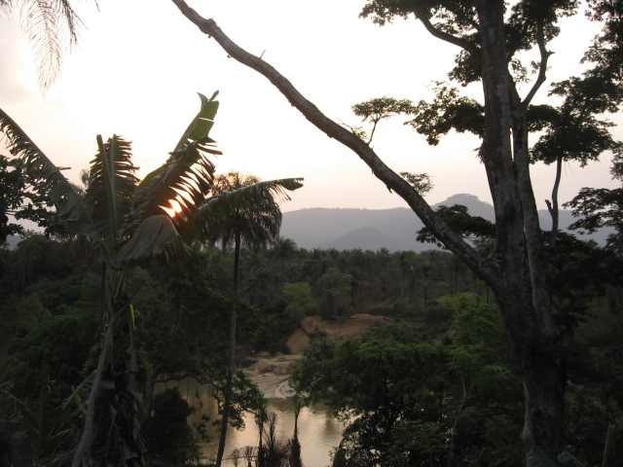
25th March
Sunrise at Reike's House
Busy day from the start. Had to get up for a call at about 4am with a miscarriage. Then sick kid in the resus. Long cue of Maternity/gynae patients needing assessment or reassurance. Unfortunately also 2 women advanced cervical carcinoma.
Finally 2 difficult labour cases. First an in utero death who presented with decreased movements yesterday who then had a spontaneous delivery with a difficult shoulder dystocia with took some time to overcome, and then another lady with APH who delivered a dead baby with a complete abdominal wall defect, whose baby presented abdominal contents followed by the breech.

28th March
Busy couple of days and hence no entry for yesterday. As I write this I’m trying to recall what happened. Without this to remind me I think much of what I have seen and done here would be lost! We had a successful Caesarean yesterday for a woman with a previous Caesarean and subsequent vesicovaginal fistula sustained during a vaginal birth. I had kept her waiting ever since I arrived before doing her elective Caesarean. Nobody here has much idea of their gestational age, nobody knows their last period, and scanning in the third trimester is known to be inaccurate by up to 4 weeks (that’s when you know how to do it). Anyway her baby came out screaming merrily and weighed 3.6 kg so plenty cooked. Have a string of scans to do every day for this and that. I think the outpatient unit now sends anyone pregnant across for a scan. It has become open season, but I actually don’t mind and I’m sure I have become much better at it as a result. In fact I have a new syndrome: Sierra Leonean women presenting with a belly and seeking maternity care, but when asked if they have had any bleeding admitting to some bleeding every month. Yesterday’s case was a woman with the enormous pelvic cyst and today’s was the fattest person I have yet seen in the country who despite presenting for her delivery after 10 months, took the news that she wasn’t actually pregnant very calmly.
The big cyst from yesterday is an enigma. I did it with Alex. The strange case of abnormal anatomy. She had a large, tense and thick walled cyst on top of an otherwise normal sized uterus. Neither tube was seen and only one ovary. I think in hindsight it may be an ovarian or tubal cyst which pushed its way into the broad ligament and over the fundus of the uterus. Unfortunately the Ketamine anaesthesia was not the best for her and she was struggling to maintain her saturations with hyper salivation and presumably blockage of her airways. Not all of it came out, but we thought that was the better part of valour.
Back to theatre in the evening with Alex for a gastric perforation. His second of the day. We found the hole and the operation went well, but he is still pretty sick and apparently the survival rate is only 50%
Doctors Alex and Josein
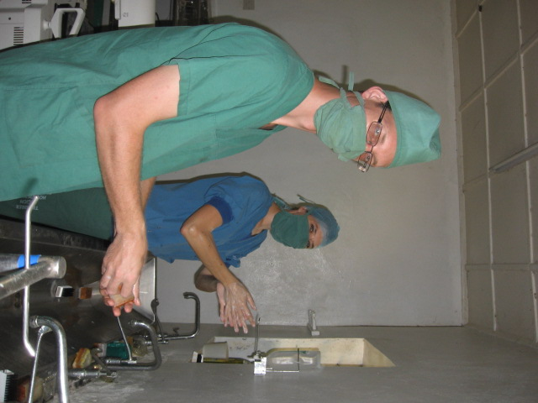
Vaginal hysterectomy and repair went well this morning, even though the operating table eclectics failed and hence down on my knees! Long string of cases referred form OPD, and the 30 weeker with antepartum haemorrhage from 2 days ago started contracting with a fever. Found her to be 4cm and decided to rupture the membranes to accelerate labour even though the baby has very little chance of survival. Again the mother took it in a very stoical way.
It is strange being in a completely different world and yet so close to home. It struck me today as being like Star Trek. We can just use our mobile phones to call up British Airways and request to be ‘beamed up’. Off to the beach with The Danes this weekend. They are really very hospitable. I’m trying to learn some words, but…
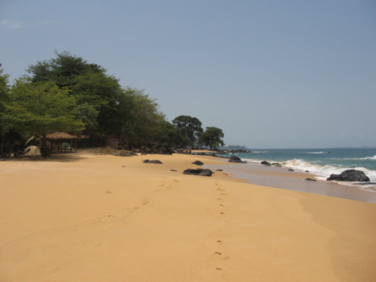
Heard an interesting tale from the morning meeting: One of the gastric perforations from last week died yesterday and due to a shortage of funds the relatives decided to transport the body by motorbike. I have often seen 4 on a bike plus luggage so I have no doubt that it is possible. Anyway with the driver and alive passenger sandwiching the body they got as far as the police check point in Matam (about 5km). Either it was too much work or the police stopped them, so they left the corpse on the side of the road in order to fetch a car, but then the body disappeared! There is talk of a resurection.
John Obay Beach
I have been educated. I got as far as diagnosing hypoglycaemia as the most likely cause secondary to malaria, but when I admitted that I had no real idea how long we could expect a bolus of dextrose to work for I was given a little master class from Alfa one of the STPs
I now know that Quinine exacerbates the effects of hypoglycaemia particularly in kids as in crosses into the brain and uses glucose often causing fits. Suggested remedy if the child can’t breastfeed is a nasogastric tube. After a few minutes of watching some poor feeding I spoke with Edward one of the Emergency Ward nurses and he suggested using expressed milk via the ngt. Sorted in a jiffy ngt and 20mls of expressed milk.
Well off to bed now and we’ll see what the night brings.

4th April
Couldn’t find the time to write last night. Wednesday was a busy day with all sorts. Thought I was going to do some extreem dentistry, but we had a case of ruptured uterus instead. It sounds like obstructed labour, with an attempt in the village to help with fundal preasure. It was quite a dramatic tear through the anterior and lateral lower segment of the uterus that had somehow been controlled with a combination of hypotension and uterine contraction. She had taken some time to get to us being referred from a neighbouring hospital. There was no option but for a hysterectomy and it went relatively smoothly. She is not fantastic today but seems a little better for some blood.
Also another Caesarean section in thenight. It took an hour from deciding to starting which isn’t too bad considering the need to locate the oncall engineer for the generator and then the theatre team. Went well and I was able to let Nyayla do most of it, although I was aware of the time taken to put the blleding uterus back together. Routinely we ask patients for a unit of blood from their relatives before surgery. This lady had some trouble finding a donor, but one of her senior relatives was eventually found. She was quite symtomatic following blood donation however and I nearly opted to give the blood back to the donar rather than the patient!
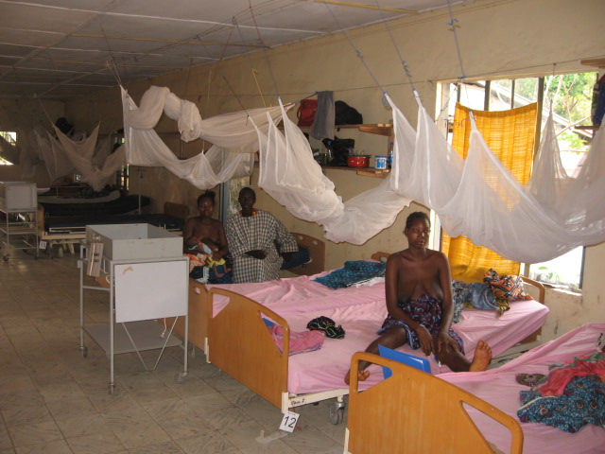
So up late both nights and sleepy today as a consequence but thankfully the hysterectomy for fibroids went well this morning and we managed to get in a sneeky vacuum delivery from the jaws of fetal distress, so a good day. Also the lady with renal failure following the PPH has started to pee and her blood preasure is normalising!
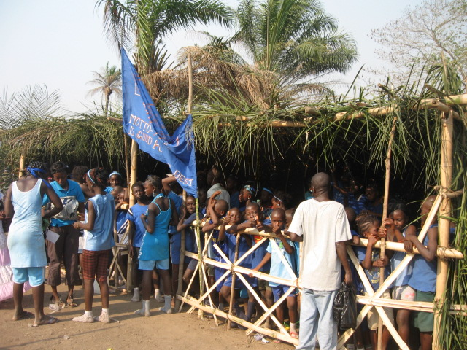
Bit of a shortage of all dispossables around the hospital currently as not much cash. Gloves, cannulas, sutures……There is a way of getting by but some of the things that happen here would not be dreamed of at home. Sharps Bins with poorly fitting lids, no running water in theatre, let alone anywhere else. It makes some of the most pressing cases seem inappropriate at times. Using the Ketamine for anaesthesia works in most cases very well, but occaisionally causes aspiration from secretions that the patients lack the refelexes under Ketamine to control. Atropine is used to control this but amongst a lot of things is currently ‘don don’. It feels strange for me to be someone who is keen to protect standards of safety when in the NHS I find myself flouting the regulations.
Sports day for the village kids today and tomorrow. It’s a big event down at the sports field behind the hospital with all kids divided up by random ballot into Blue, Yellow, White and Pink houses. All maner of running and jumping competitions taking place. There is a great spirit to it. There is an adult version in a couple of weeks time to which we hospital staff have been invited to attend. I’m not sure yet which ‘house’ I’m in. It’s clearly a big event in the callendar, should be fun.
Blue House

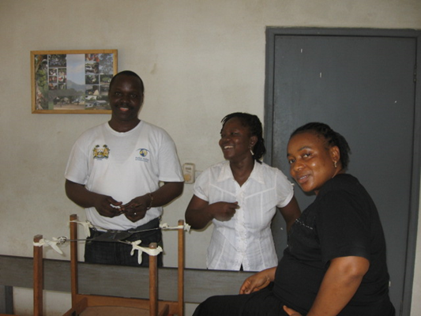
5th April
2 successful vacuum deliveries today. One of the difficulties of working in a completely different environment has been making the appropriate decision. The first was for a woman with some decelerations who had very little motivation to push which is unusual here but the vacuum (recycled KIWI cups) went fine. Second case was an exhausted and semi-conscious lady who came alive when attempting to deliver her baby with a vacuum. I thought of Steve Irwin wrestling with a crocodile. I was trying to calmly reassure and direct Joseph with the vacuum, whilst Mohamed and I held onto the bucking bronco car abash, as it proceeded around the delivery room.
STP Students: Joseph, Sharmi and Nyala
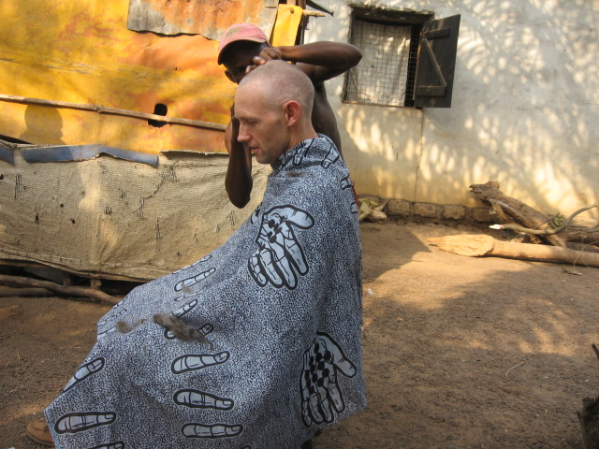
The haircut!
I’m not sure it was the best idea but having my head shaved in an African village is certainly an experience. To be fair a very professional job and it should last me a few week! I had asked Education where he had his hair done and without really thinking about how the procedure would be undertaken I followed him to his man in the village. Mohammed did a great job with scissors, a comb, and razor blade. It drew a little crowd who thought I resembled an angel! Very nice hairdo Dr.
On call the weekend as The Dutch were keen on a weekend away at Bumbuna together. I should say they probably deserve a weekend away together to share their experiences here over a few beers. I might see if I can cycle there next weekend when the Danes are planning a trip. The weekend after is looking like the mountain.

8th April.
An interesting weekend with a mostly obstetric flavour on Saturday and Paediatrics/Cardiology yesterday. We had a 6 month boy with convulsions who died, unexpectedly as I thought he was doing quite well Malaria responding to treatment. Also a 13 year old with polyarthropathy, peripheral oedema, pleural rub and shortness of breath. ?Rheumatic fever. Had to keep the generator running for oxygen for him in the night…….
Also managed to get Sharmi to do the whole Caesarean yesterday. An achievement for both of us, especially given her bloodloss before we started and my anxiety regarding any further bleeding, (she came with a 2 day history of bleeding, Placenta Preavia and dead baby).

The maternity ward is chocker block. We have had a flurry of deliveries over the last week or so with 3 or 4 deliveries a day up from 3-4 per week. Still we see all sorts and a quick tour of the ward goes like so:
- Day 5 following C/S for obstructed labour
- Day2 C/S Placenta Praevia
- Day10 C/S home today
- Antenatal, about 37 weeks in for safe delivery
- Day3 Eclampsia, IUD and Vacuum delivery
- Day8 Ruptured Uterus, Subtotal Hysterectomy
- Day3 Vacuum (Fetal Distress), Followed by large PPH
- Antenatal waiting mother about 39 weeks
- Day 1 C/S Placenta Preavia, IUD
- Day 8 C/S, prolonged labour, APH, Shock and Renal Failure, now resolving
- Day 8 C/S Obstructed labour
- Day 7 Still Birth, PPH or the way to hospital, pain in hips and back ?cause
- Day 5 Ruptured Uterus, Subtotal Hysterectomy
- Antenatal, about 20 weeks, joint pain, fever lethargy ?Malaria
- Antenatal, 2 previous Caesareans, booked for Elective C/S tomorrow
- Antenatal 39 weeks, previous abdominal surgery in childhood, for safe delivery
- Antenatal 22 weeks, loin pain, fever, probably UTI
Can’t remember the rest but I think there are 2 more with 1 spare bed, although there is more space on the floor!
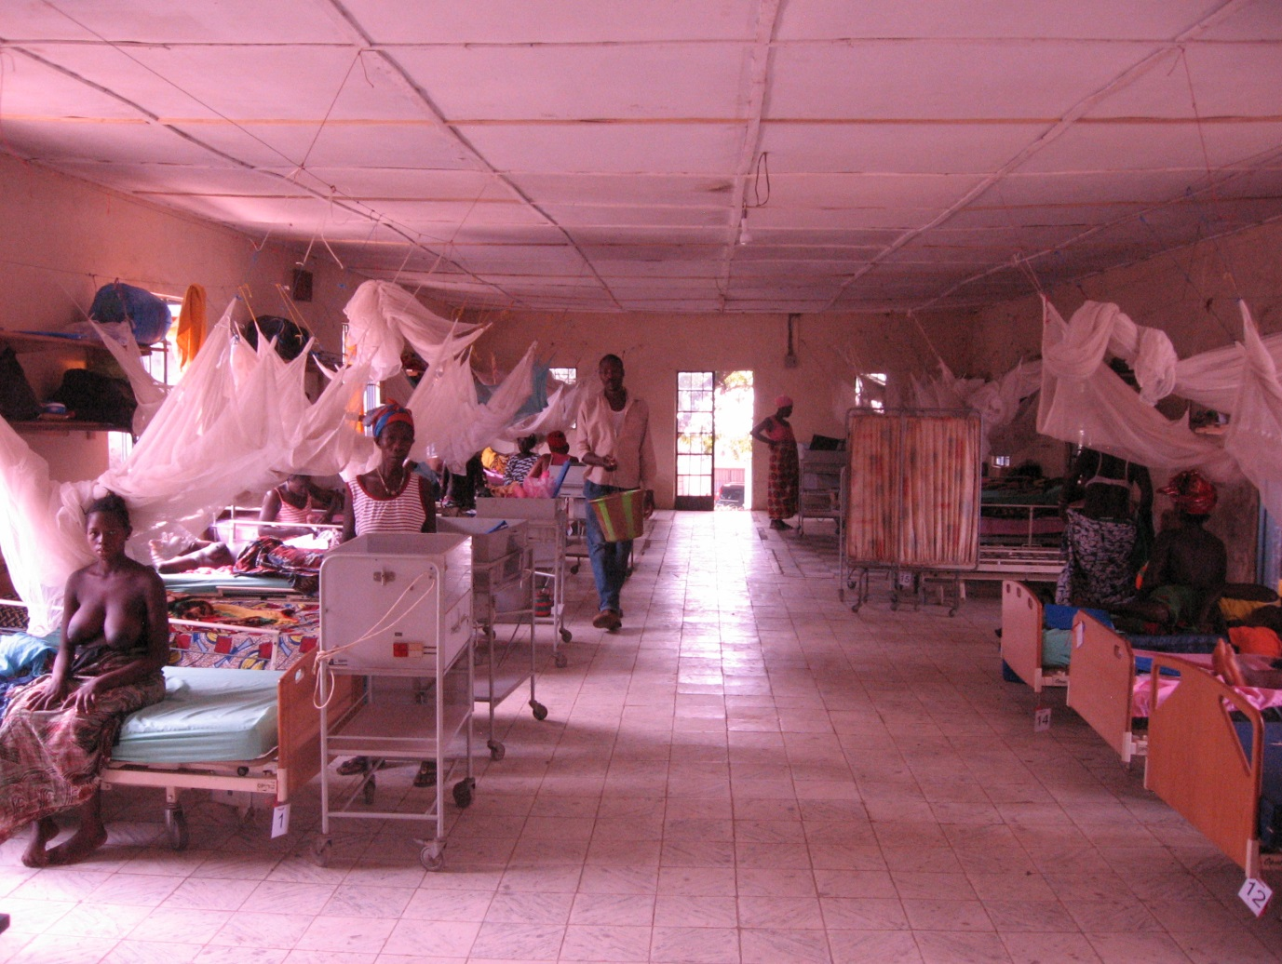
Maternity Ward

9th April
Hot and sticky+
Spoke to the kids on the phone who told me how cold it is at home. The both sound older and wiser in the 6 weeks I have been away!
Took Joseph through an elective Caesarean today, which took quite some time……Not so easy as she had had 2 previous and he had to battle with a loose needle with ties, but got to get him some stitching practice.
We have run out of Ketamine today so any Caesareans in the night will be done under local!
Also had a man in OPD today with Impotence, but no Viagra in the pharmacy either. One of the few luxuries here is the lack of internet, and hence no chance of being offered unsolicited Viagra. I have no doubt that if internet were available people would be all over it, just as they are with mobile phones. Despite my retarded views on modern coms, it is really a solution for Africa.
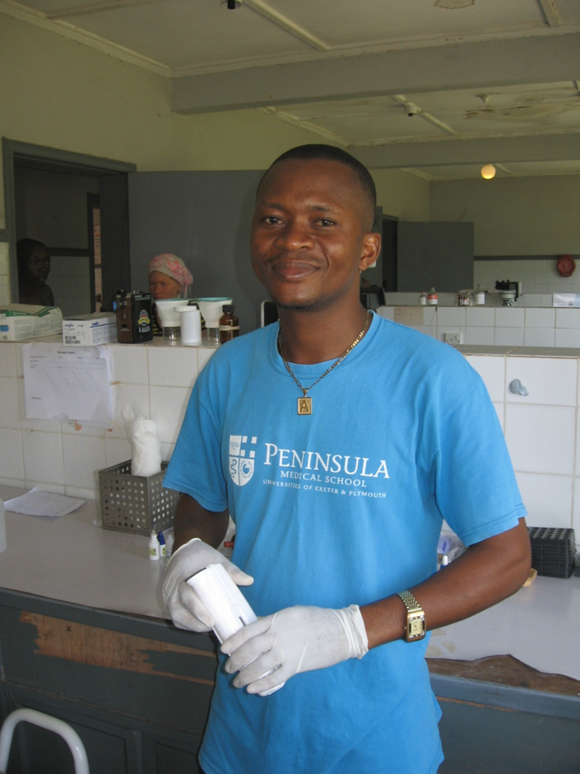
10th April
An easy day today. Even found time to visit Alfred and Esai in the lab to see what they do. It’s a fairly simple set up but they are busy. The Hb is measured in grams per decilitre, which is the same as for the UK, but the technique is fairly crude and at the moment is lacking a haemolysing solution which I’m sure affects the reliability of the technique. They blood bank is really a life saver here. There are about 10 units in the fridge which is temperature controlled and run from a battery bank when the generator is off.

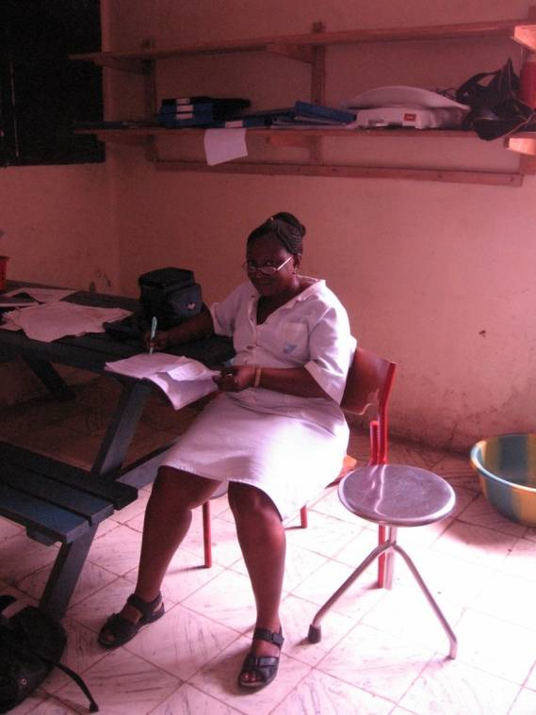
Alfred

Mama G in charge of maternity ward. I thought I’d met some bossy midwives before but she is a strong willed woman! Here she is busy preparing a Fire and Brimestone for church on Sunday.
The story of the evening was a Trojan Horse type event where a mother of a 4 year old on the paediatric ward suddenly went into labour at about 1am and popped out a set of twins. 2000g and 1000g.She now has 6 children from 7 pregnancies and looked less than impressed with the idea of twins. I don’t think she has the strength to look after these two and I think the small one is too small to insist on his milk. I offered her a sterilisation but she needs to talk with her man first.
Mama G

11th April
Supper at the hostel, chatted to the Danes. Discovered a bit about what Christina has been doing with her project. She has been interviewing women to ascertain their success or otherwise in childbirth. Most women have lost at least 2 children. She found only 3 from 75 who have not lost a child. It seems that most women see this as inevitable. Looking through our delivery record we have a stillbirth rate of 25%. By way of comparison the perinatal mortality rate at home is about 6 in a thousand and includes all deaths in the first week of life.

Mount Bintamani.
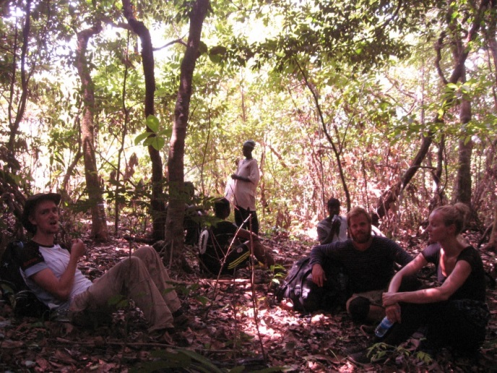
A really magical place. The effort of getting there was worth it, althoughthe travel, negotiation re fees and porters was all a bit fraught. It is really still a wild place although I am sure that the local population has made some impact on the numbers of wildlife in the area. There is a terrific feeling of space, tranquillity. We saw some Chimpanzees from a distance. Amazing sight.
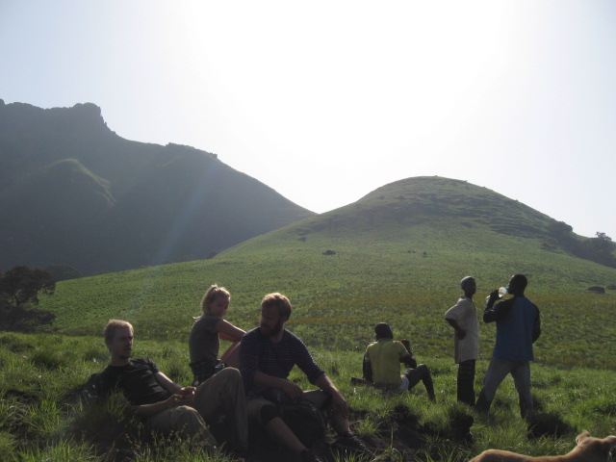

Back to work and on call tomorrow. Only just over 3 weeks to run. David and Jo have made it here from the UK in their car. Loads of questions about Masanga and suddenly I’m seem quite the expert!

24th April
Good day at Masanga, although all change. Bart and Josein headed off to the airport this afternoon leaving Alex, myself and now David at the helm. I am on call this week and it has been busy enough so far….Monday saw a uterine rupture that I took to theatre with the STPs to very ably assist me whilst Joseph dealt with a normal labour. She was proper shocked and I did wonder if she would make it but is now doing well. Luckily the uterus came together thus avoiding a hysterectomy. Retained placenta in the middle of the night was also super shocked but had the miracle of blood to save her
Yesterday started with the strangulated hernia that I roped Alex in for at 7am, then followed by an elective Caesarean, a colpocliesis, abdominal hysterectomy and vaginal hysterectomy. Last night we had 3 labourers, one referred in to us with Eclampsia, who sadly despite progressing well from 8cm to fully had a failed vacuum and then a Caesarean with a neonatal death. At least she is doing well this morning and a testament to resilience.
Had a good teaching session with the STPs today going through the basics of knots. I managed to put together a model with some gloves instruments and some rubber tubing and it was very well received.

26th April
Dawn. Memorable day yesterday, just no time to write. Had a quite night on call Wednesday and Thursday which makes up for the flogging on Monday/Tuesday. Started with an Abdominal Hysterectomy for a 20 week sized fibroid. Started well enough, but she became a bit unsteady on the Ketamine as she salivated and then started to aspirate. It all became a bit of a struggle and so I called Alex in to give us a hand to just get through the procedure as quickly as possible. She ended up with a subtotal hysterectomy and losing both ovaries. The subtotal bit is no real issue, but losing the ovaries is far from ideal as she is only 37. I will see if It is possible to find some kind of COCP to use as HRT.
As that was unfolding Mohamed and Dida delivered a Breech that I had been planning to do an ECV for. She had pre-eclampsia with a BP of 170/100 and I didn’t really want to have to actively induce a grand multip breech, but she laboured spontaneously, so good result.
Then had a gold miner in with an open fracture dislocation of the ankle to spice up the theatre schedule. Next onto an old lady with prolapse from the Better Life Foundation. Next a large chest wall lipoma.
David ploughed through the referrals from OPD and we then jury rigged a chest drain from an old Vacuum Extractor flask.
Football at the sports week. I think Blue House won on penalties.
Supper at Alex’s house with David, Jo and Anna-Marie. We had a long chat about the challenges facing the project, which are mostly administrative, but enormous. Alex is leaving just a week after me and of course he is keen to hand over the running of the hospital to others. Enter David and Jo. What a task! The project has grown massively in the last few years and has been largely an amateur/pet project, but is now getting too big. There are also lots of people with fingers in the process. The International Board has been set up to try and co-ordinate, but how do you run a hospital in rural Africa from Europe? A field manager is required. Who should it be?..........

26th April
Skin grafting amongst others sports today.
Much action at the sports day with some seriously impressive high jumping.
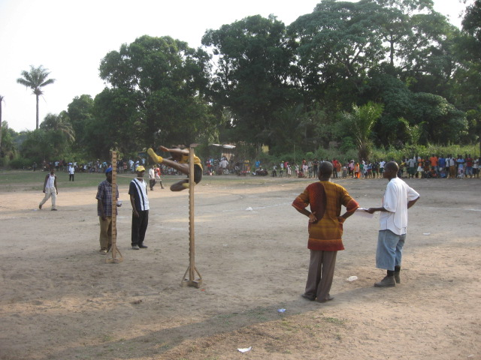

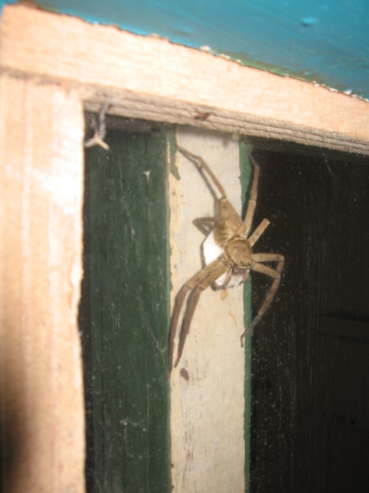
Theatre Pet

Otherwise mostly quiet. The big event today is the sports which passed off with great fanfare down on the sports field. It is Independence Day today and because of it being Saturday it’s likely to be a public holiday on Monday. Usually there is one every other week!

30th April
Late night last night with a flurry of emergencies. Laparotomy for an intraperitoneal abscess which I did with Alex and fortunately he was back from Yele just as we were taking him to theatre, then a Caesarean for obstructed labour. Sharmi did most of it and it’s good to see the skills of the STPs improving. It’s also probably my confidence in the environment and willingness to give them the chance….
Well I’m no longer 2nd on call having just done the last week. There were a few days when I didn’t get called but I still feel pretty knackered! Alex is doing this week and me the following. With Josien away there is a fair amount to do. We do have both David Potter and David Connor from Plymouth here now so they are taking fair bit of the non-surgical stuff. I have moved into Bart and Josein’s house to make some space for them all and as I will be gone by the time Josien is back. It is in truth a much more pleasant place to live, with stove, and hence coffee (now brewing), toilet seat, comfy chairs, no mice seen yet and some homely pictures on the walls…..I am expecting the others around for b’fast as Rugi is sick with Malaria. She is now 7 months pregnant and has been complaining of a headache for some days. I was hoping to see her today for a sort of antenatal review, but heard yesterday that she had been to the clinic and tested positive for Malaria. It is a common problem in pregnancy here, but she should be fine now she has he treatment.
Cooler this morning and rain on the roof to wake me up. The seasons are changing. Just over 2 weeks to go.

3rd May
Oh oh oh…….
Last night. 3 Still Biths. One was a 26 week Intrauterine Death who we eventually got to deliver normally with Misoprostol. Much easier with Mifepristone first, but not available here. Second was a 29 week placenta praevia who came in bleeding heavily. I thought I could feel a leg and tried to bring it down in order to compress the placenta and arrest the bleeding whilst the cervix dilated. It turned out to be the arm however. Took her to theatre and managed an internal version and breech delivery, but she then had a large PPH in theatre and then again on the emergency ward afterwards. Managed to get away with it with sustained massage from Ishmael and an intrauterine balloon fashioned out of a catheter and a condom. 2 units of blood, this morning all seems fine. The third was a cord and hand prolapse. Buoyed on by my success with the other case we tried again an internal version, but only managed to rupture the uterus. I then had a devil of a job putting the uterus back together and again she needed 2 units of blood. Choose the cases!
Today Brow presentation, 2 lipomas, and just now a failed vacuum in a primip with meconium and I went for a Symphisiotomy. It worked but the baby died anyway……..Better outcome than the other evening though as we avoided a C/S. I think the lesson is to not hang around following the referral from elsewhere of women who have been in labour for some time already. I can think of 6 cases now and only one has responded to Oxytocin anddelivered normally. This latest delivered only with a symphisiotomy and a dead baby. 2 have ended with Caesareans with babies with poor Apgar’s who later rallied, and 2 had Caesareans but the babies died anyway.
It’s been a long but really very memorable week. Off to Bumbuna with Double Dave’s and Jo tomorrow.

5th May
Great weekend at Bumbuna. No fever this time and chance to get stuck into some good food and beer. Refreshed enough to contemplate 10 more days of extreme O&G.
Unfortunately we had another Maternal death over the weekend. I’m not sure what happened. She had come into the hospital 2 months following delivery elsewhere with a prolapse, but was also feverish and thin. I was treating her for Malaria as her parasite screen was positive, but on Saturday morning she took a sudden turn for the worse. Despite resuscitation on the Emergency ward she died later on the Saturday. Also the tiny twin that was born about 3 weeks ago died yesterday.
Well the ward is rammed and we now have O&G patients all over the hospital. 3 more Caesareans over the weekend will have pushed up the long stay numbers. I reckon I can move at least 3 on tomorrow however.

10th May
Yesterday was a good day. Perhaps the best. Having slept badly I was concerned about the 2 Hysterectomies I’d booked, but they went well, despite both being fairly difficult. Having just finished the first case and having a rest small, the lady with 3 previous still births had a shoulder dystocia. No pressure! Fortunately it came, and with the help of Dave successfully resuscitated. Fairly emotional.
Slept well and was out running this morning when the call came through for an obstructed labour. Claudia and David called into the Breech! Story of labour for 2 days, but just as we were getting ready for the C/S she delivered. That’s obstetrics!

12th May
Young woman with abdominal pain, unusually short last period, fever, hypotension and tachycardia. Her Malaria screen was positive, as was her HCG. I scanned her hoping to see an intrauterine pregnancy and blame it all on Malaria, but she had an empty uterus and a small mass behind it. I thought the best option was to take a look rather than ignore it. Thankfully she did have an ectopic, as well as Malaria, and she had been bleeding. She is on the mend this morning.
Sadly the PPH lady died in the night. I feel we did all that was possible here in Masanga, although I do feel a little nialistic about it. That makes 5 maternal deaths since I have been here. (Eclampsia, Hepatocellular Carcinoma, PPH, Sepsis and Cardiac/Renal failure).
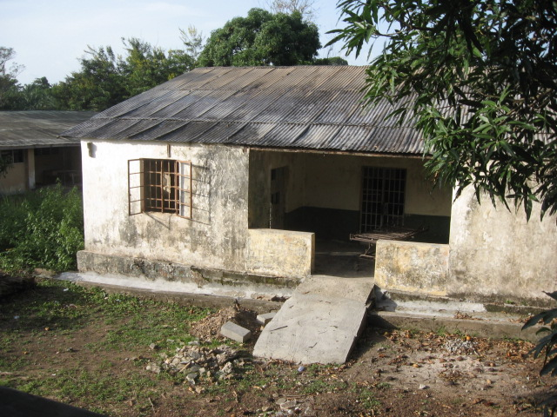
Went to ‘church’ this morning, having been invited/ordered again by Mama G. A good song and dance.

The 3 operations from the weekend all getting a little better. Busy day on the emergency unit with an influx of sick kids. This is a mammoth task and none of us feel particularly well equipped to deal with it. We are losing many children. Sierra Leone has a childhood selection regimen that makes Sparta look like Disneyland.
15th May
Spoke to home last night. We have 5 new chicks. If all goes well I’ll be home Thursday. It has been a really wild few weeks. I count myself fortunate to have had the opportunity. Despite the hardships, people have a humour and charm that rubs off on you. I came for an adventure and certainly got one. To have been able to pass on any skills to the STPs has been a pleasure. I am sure that they have saved lives through their obstetric management of PPH, Breech delivery and Obstructed Labour.
Thank you Masanga.
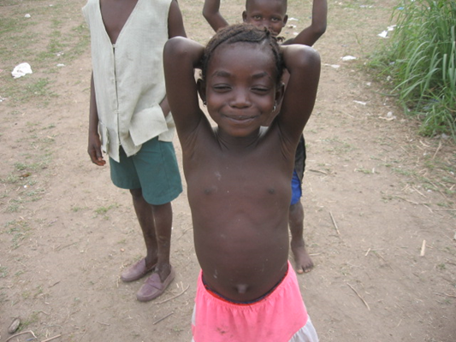

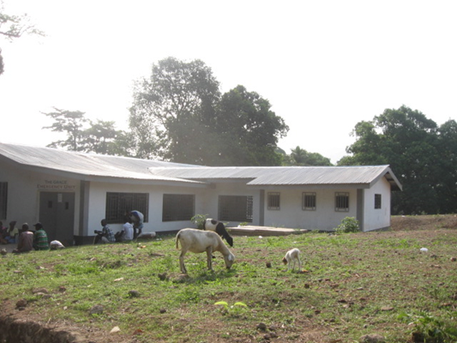
Snap me!
Emergency Ward

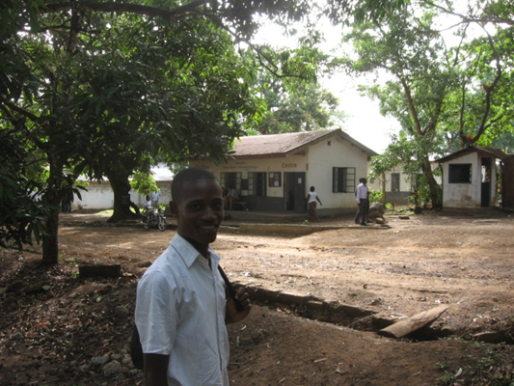
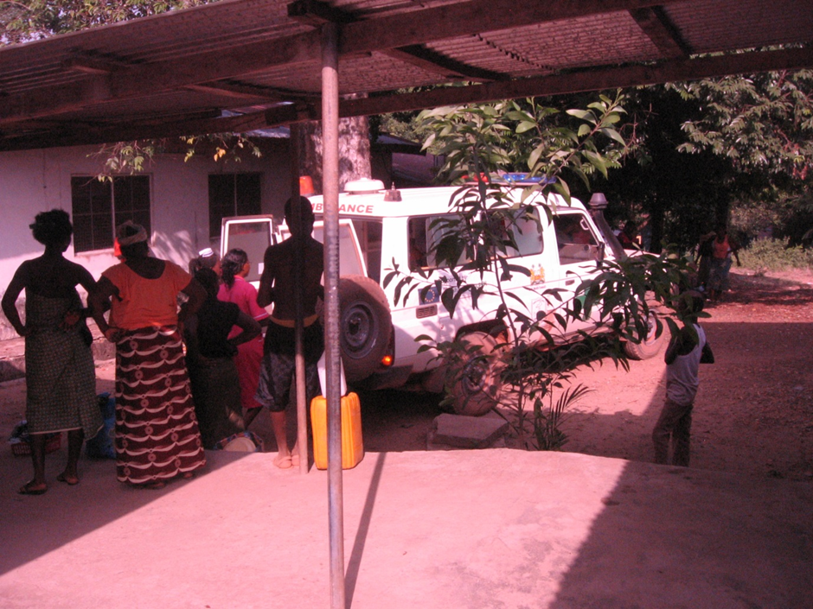
Magburka Hospital has a fine Ambulance Service. Not such a good Maternity.

Almany, Community Health Officer.
The start of another day at Masanga.

